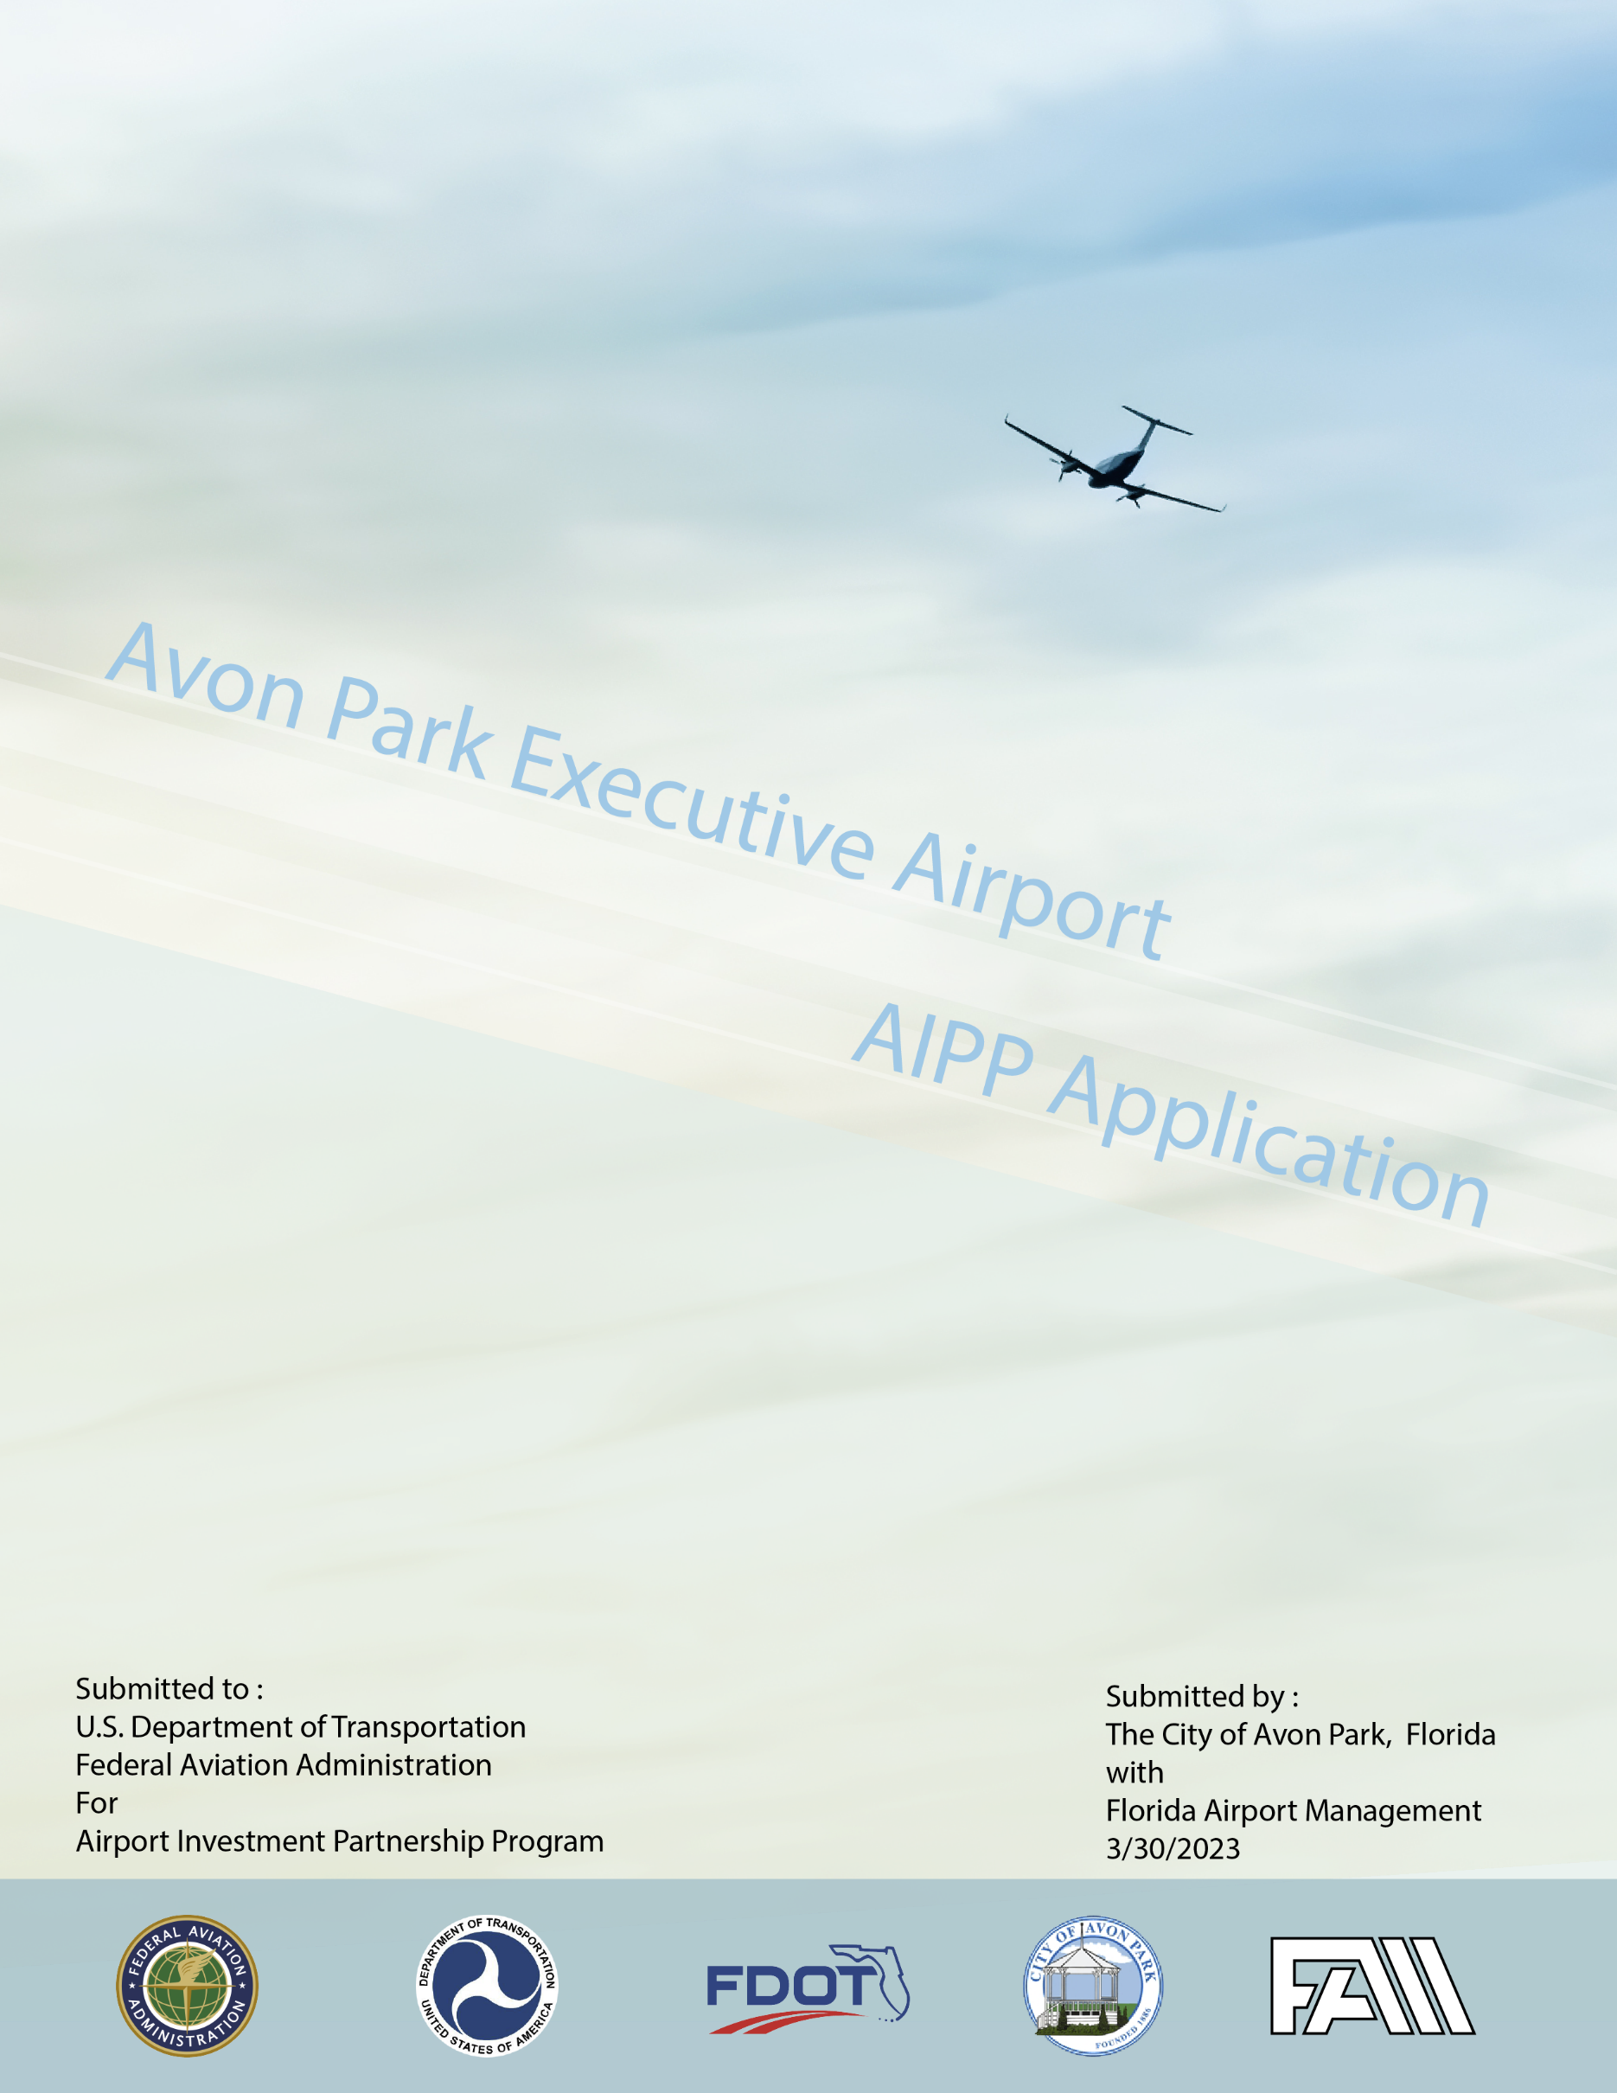
Contents
AIPP Application 5
Background 5
Part I. Parties to the Transaction 7
☒A. Name of the airport proposed for sale or lease. 7
☒B. Name and address of the public sponsor of the airport; name, address, telephone number, and email address of the person to contact about the application. 7
☒C. Name and address of the private operator proposing to purchase or lease the airport; name, address, telephone number, and email address of the person to contact about the application. 7
☒D. If the private operator proposing to purchase or lease the airport is a partnership, joint venture, or other consortium of multiple interests, the name and address of each of the participating members. 7
☒E. Citizenship of the private operator or each member of the private operator consortium, and percentage of interest of each such member. 8
☒F. If the public sponsor will retain an interest in the new operating entity and share ownership of that entity with a private investor, the percentages of ownership to be held by the public sponsor and the private investor respectively. 8
☒G. A statement of the public sponsor’s authority to sell or lease the airport, with a citation to legal authorities. 8
☒H. If the public sponsor will share ownership in the operating entity with a private investor, a statement of the public sponsor’s authority to participate in a private enterprise. 8
Part II. Airport Property 9
☒A. For each airport included in the application, a description of the airport property to be transferred. Applicants should describe property in sufficient detail to identify the parcels of property and facilities to be transferred. 9
A.1 General Description of Airport 9
A.2 Legal Description of Property 9
A.4 12
Equipment Descriptions 13
☒B. A history of the acquisition of existing airport property. Applicants should include information on grants, types of deeds, the dates and means of conveyance, e.g., 13
☒C. An explanation of any differences between the airport property to be transferred and Exhibit A to recent AIP grant agreements. 14
☒D. Evidence of Good Title to the airport property satisfactory to the FAA. 14
Part III. Terms of the Lease Transfer 15
☒A. A detailed description of the terms of the lease transfer, other than financial, including: 15
☐C. Copies of all documents executed as part of the transfer, to be provided as they are executed or are in sufficiently final form to indicate the substantive nature of the expected final document. 19
☒E. Provisions of a document conferring third-party beneficiary rights on behalf of the FAA to enforce, directly against the private operator, key obligations contained in AIP grant agreements and the assurances required by section 47134. 20
Part IV. Qualifications of the Private Operator 20
☐A. A complete description of airport management and operations experience, including the identity, experience, expertise, and responsibility of key personnel. A description of the facilities and airports presently being managed by the company, both domestically and internationally. If the private operator is a newly formed entity, describe the experience of the constituent members and the proposed management structure to integrate operational functions. 20
FAM 20
FAM AVO Year One Achievements 20
Our Team 21
FAM Detailed Organizational Structure 21
Our Experience 23
☒B. Financial resources for operating/ capital expenses of the airport. Copies of the 10K annual reports filed in the past three years with the Securities and Exchange Commission, if filed. If 10K annual reports were not filed, provide a balance sheet and income statement prepared in accordance with Generally Accepted Accounted Principles, with all footnotes applicable to the financial statements. The private operator should have a letter of credit equal to cash reserves of six months for the initial operation of the airport unless a lower amount is approved in advance by the FAA. 23
☒C. Timing and details of application for Part 139 certificate, if applicable. 23
☒D. Plan for compliance with 49 CFR part 1542 is approved with FDOT. 23
☒E. A description of the private operator’s capability and experience of complying with the public sponsor’s existing grant assurances, including the assurance of compatible land use around the airport; the protection of navigation aids, approach lights, runway safety areas, and runway protection zones; and the continuation and extension of navigation easements. 24
☒F. Affiliations with air carriers or other persons engaged in aeronautical business activity at an airport (other than airport management). 24
N/A 25
☒G. A description of all charges of unfair or deceptive practices or unfair methods of competition brought against the private operator and private operator’s key personnel; and, in the case of a private operator that is a joint venture, partnership, or other consortium, the separate members of the entity in the past 10 years. The description should include the disposition or current status of each such proceeding. 25
Part V. Requests for Exemption 25
☒A. Describe the specific exemption requested by the public sponsor under 49 U.S.C. 47134(b)(1), from the prohibition on use of airport revenue for general purposes, including the amount of funds involved. The description should include sale or lease proceeds as well as funds in existing airport accounts that would be transferred to general accounts. 25
☒B. Describe the specific exemption requested by the public sponsor under 49 U.S.C. 47134(b)(2) from the requirement to repay Federal grant funds or return property. 26
☒C. Describe the specific exemption requested by the private operator under 49 U.S.C. 47134(b)(3) from the prohibition on use of airport revenue for general purposes. The description should include the anticipated amount of airport revenue to be used for compensation of the private operator, the source of airport funds involved, and a description of the effect, if any, on air carrier and other aeronautical user fees. 26
Part VI. Certification of Air Carrier Approval 27
☒A. For an application relating to a primary airport: 27
☒B. For an application relating to a nonprimary airport: 28
Part VII. Airport Operation and Development 28
☒A. Provide a description of how the private operator, the public sponsor, or both will address the following issues with respect to the operation, maintenance, and development of the airport after the proposed transfer (See Appendix VII. A, ORTP 2023). 28
Part VIII. Periodic Audits 37

Figure 1 - City to Airport Vicinity Map 5
Figure 2- Airport Aerial Map of Existing 442.6 Acre Property and Facilities 9
Figure 3- List of Equipment and Tangible Asset (Source: City of Avon Park, 2023) 12
Figure 4- Property Map from the Avon Park Airport Master Plan (Signed 11-16-2016) 15
Figure 5- Chart Showing APMPU 2014 Projects Executed V. Need to Be executed in 2015 Dollars. 30
Figure 6- Chart Showing Anticipated Percentage of Contribution by entity on 5-Year CIP Projects 30

Attachments – The Attachments are in separate documents due to the size of the overall attachments there is a Table of Contents to the Attachments included with these documents.

AIPP Application

Background

City of Avon Park
The City of Avon Park is located in Highlands County, Florida, in the center of the State. The location of the City is shown in Figure 3 below at the intersection of Florida State Road 64 (east-west) and US-19/27 (north/south). The City has a population of approximately 10,000 residents. The area around Avon Park is mostly agricultural ranching and orange groves. The Orlando International Airport is just over 70 miles away to the northeast for reference purposes.
Avon Park Executive Airport
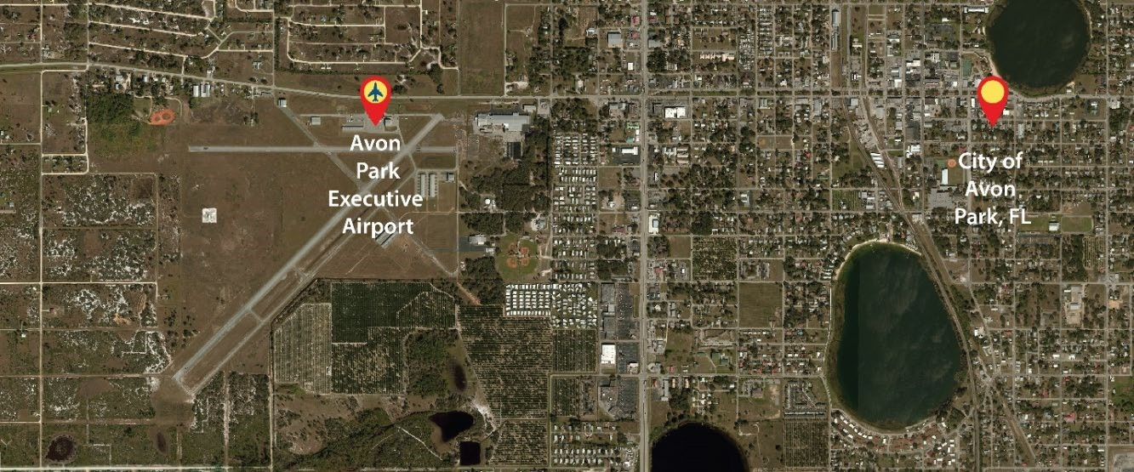
The City of Avon Park owns and operates a general aviation airport that is on Florida State Road 64 west of Avon Park as shown here. The airport is known locally as the Avon Park Executive Airport and KAVO or AVO.
Figure 1 - City to Airport Vicinity Map
As noted in reports over the years, KAVO has operated at an annual deficit. The City of Avon Park has provided financial and operational support for the Airport for annual operations and other key activities, such as environmental remediation.
The City of Avon Park has not had permanent leadership or staff for the Airport for some time and instead has used various staff from existing City Departments to assist in the daily activities of the Airport. The City was considering hiring a contracted Airport Manager when the City received interest from a private party for a long-term private lease for the Airport.
Unsolicited Proposal/Procurement
This interest was formalized, and the private party submitted an unsolicited proposal to the City of Avon Park under Section 255.065, Florida Statutes on March 31, 2021. The City of Avon Park requested additional follow-up information and, after receipt, staff and advisors evaluated the proposal. The City Council was advised of receipt of the unsolicited proposal at their public meeting on April 12, 2021, and provided a summary of the unsolicited proposal for consideration at their public meeting on April 26, 2021. The City Council voted in favor of advertising for a period of time as required by Section 255.065, Florida Statutes, to notify the public that an unsolicited proposal had been received and to open up the advertisement for any other interested parties that may wish to propose to the City for a long-term private lease of the Airport. No other proposals received during the advertisement period. The City Council voted in a public meeting for the City Manager to develop a draft lease document with the private party for consideration by the City Council. This process was conducted over a series of meetings during July and August 2021 and a draft lease agreement was presented for consideration by the City Council at their public meeting on August 23, 2021. The City Council voted to accept the draft lease agreement and for the City Manager to provide the draft lease agreement to FAA and the Florida Department of Transportation (FDOT) as major grant agencies for review and consideration.
The City of Avon Park Team (City Manager and advisors) provided an overview of the procurement process and current discussions on a draft long-term lease with a private partner to the FAA Orlando District Office on June 29, 2021.
Drafts of the lease agreement were provided to FAA and FDOT for comment in early September 2021.
FAA Feedback, AIP Grant and Next Steps
Based on the review of the draft lease agreement, meetings were held with various staff of FAA including Headquarters, Region and District. The final result of these discussions was a recommendation from FAA in February 2022 that the City and the private partner submit an application under the FAA Airport Investment Partnership Program (AIPP) to better fit the proposed long-term lease with a private partner for KAVO.
The City of Avon Park advised FAA that due to limited budget the City would be unable to provide the due diligence for the more detailed AIPP application process without support from the up to $750,000 that FAA can provide under the AIP grant process for due diligence for AIPP application processes. The City Council in their public meeting in February 2022 voted to move forward with the AIPP application process, subject to receipt of a FAA AIP due diligence grant and also to move forward with contracting with the private partner for an Operations Agreement as soon as possible. This was discussed with FAA Headquarters and Region in March 2022 and the feedback provided was supportive of this approach.
The private partner was contracted in April 2022, after review and approval by the City Council, for an Operating Agreement to manage the Airport. The private partner, Florida Airport Management, LLC (FAM), has been operating the Airport since this time.
FAA provided an initial grant award notice for $432,000 in September 2022, with City match of $48,125 to total $480,125. After discussion of the scope and other items FAA provided the grant authorization in early November 2022.
The City has been working with FAM to develop and provide due diligence on all elements of the AIPP application that is included below. The City Council had a detailed public meeting on February 23, 2023, that was focused on the AIPP application and the draft lease agreement. These discussions focused on the financial provisions of the lease agreement and the City Council provided policy input to help finalize the lease agreement. The City Council had a detailed public meeting on May 4, 2023, to review the AIPP application and draft lease agreement. The City Council voted to move forward with submitting the AIPP application to FAA.

Part I. Parties to the Transaction

☒A. Name of the airport proposed for sale or lease.
Avon Park Executive Airport

☒B. Name and address of the public sponsor of the airport; name, address, telephone number, and email address of the person to contact about the application.
CITY OF AVON PARK, Sponsor
110 East Main Street
Avon Park, Florida 33825 City
Melody Sauerhafer
msauerhafer@avonpark.city
863-452-4410

☒C. Name and address of the private operator proposing to purchase or lease the airport; name, address, telephone number, and email address of the person to contact about the application.
FLORIDA AIRPORT MANAGEMENT KAVO, L.L.C., Lessee
1535 FL-64. Suite 101
Avon Park, Florida 33825
Jonathan T. Clark
Jt@rocigroup.com
407-340-0080

Florida Airport Management KAVO L.L.C., is a subsidiary of Florida Airport Management LLC, and was created as a special purpose entity for this transaction.

☒D. If the private operator proposing to purchase or lease the airport is a partnership, joint venture, or other consortium of multiple interests, the name and address of each of the participating members.
Florida Airport Management KAVO, LLC is a subsidiary of Florida Airport Management, LLC.
(FAM) established in 2020. FAM is a subsidiary of The ROCI Group, Inc., a Florida Corporation established
in 2021. The ROCI Group is a C-corporation and is functionally the management company for all holdings
with an Executive Team guided by a board of directors.

Jonathan Clark is the primary Shareholder owning 700 shares of Class A voting stock and 33,273,823 of
Class B non-voting stock. The remainder of Class A and Class B shares are distributed to the treasury of
the company and have been distributed on merit to employees as equity within an Employee Stock
Ownership Structure (ESOP). For a summary of the company structure see Appendix Part I.D.)

Articles of Incorporation for Florida Airport Management KAVO, LLC and Operating Agreement (See Appendix Part I.D)

☒E. Citizenship of the private operator or each member of the private operator consortium, and percentage of interest of each such member.
The private operator is a US Citizen and Florida Airport Management KAVO, L.L.C. is a US Company duly organized in the State of Florida as shown in Attachment Part I.D.

☒F. If the public sponsor will retain an interest in the new operating entity and share ownership of that entity with a private investor, the percentages of ownership to be held by the public sponsor and the private investor respectively.
N/A Public Sponsor has no interest in the new Operating Entity.

☒G. A statement of the public sponsor’s authority to sell or lease the airport, with a citation to legal authorities.

The City of Avon Park is provided the legal authority for a long-term lease of City assets such as the Airport from the following:

- Section 2(b), Art. VIII of the State Constitution, provides that municipalities shall have the governmental, corporate, and proprietary powers to enable them to conduct municipal government, perform municipal functions, and render municipal services, and may exercise any power for municipal purposes, except when expressly prohibited by law.
- Section 166.021, Florida Statutes, provides the overall powers of municipal governments in the State of Florida, which are broad and general in nature based on what is commonly termed, “Home Rule Authority” meaning that municipal governments such as the City of Avon Park may provide government services in the manner deemed appropriate unless specifically restricted by Florida Constitution or Florida Statutes.
- Section 255.065, Florida Statutes, provides the authority for the City of Avon Park, as a duly created local government to provide for a public-private partnership of City assets including the Airport.

A more detailed opinion on the legal authority for the City is attached as Attachment Part 1 G.

☒H. If the public sponsor will share ownership in the operating entity with a private investor, a statement of the public sponsor’s authority to participate in a private enterprise.
Does not apply.

Part II. Airport Property

☒A. For each airport included in the application, a description of the airport property to be transferred. Applicants should describe property in sufficient detail to identify the parcels of property and facilities to be transferred.

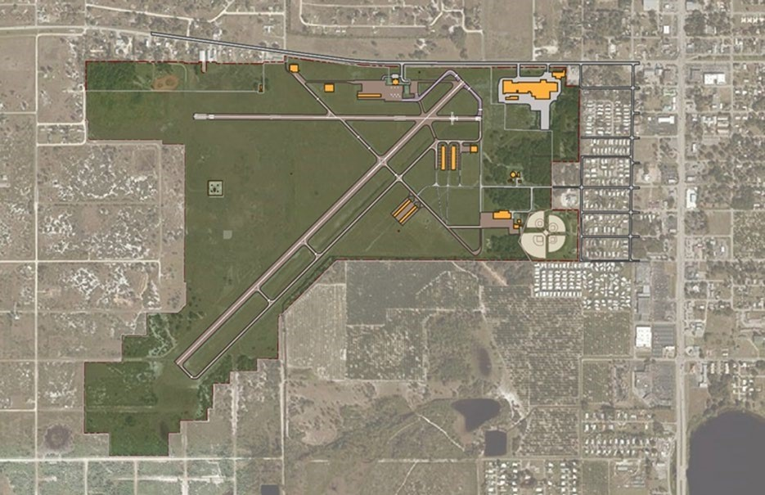
A.1 General Description of Airport

Figure 2- Airport Aerial Map of Existing 442.6 Acre Property and Facilities
AVO is located in and owned by the City of Avon Park (City). The City is in the Northwest corner of Highlands County, Florida, which is in South-Central Florida, northwest of Lake Okeechobee. Avon Park Executive Airport (the “Airport”), FAA identifier ("AVO") is a city-owned, public-use, general aviation airport located two nautical miles (3.7 km) west of the central business district of the City of Avon Park. The Airport covers 442.6 acres and has two asphalt paved runways with lengths of 5,374 (Runway 5/23) and 3,844 feet (Runway 10/28). The Airport averages 88 flights per day and 48 based aircraft which includes single-engine, multi-engine, jet, and helicopter aircraft. Currently under Miami’s air traffic control system, the Airport has an Automated Weather Observing System (AWOS). AWOS provides continuous, real-time information and reports on Airport weather conditions.

According to the Federal Aviation Administration's (FAA) National Plan of Integrated Airport Systems (NPIAS), AVO is designated as a general aviation (GA) airport. The Florida Department of Transportation (FDOT) classifies the Airport as a community airport in the Florida Aviation System Plan (FASP), serving the flight training and recreational needs of the community (Source: APMPU, 2014).

A.2 Legal Description of Property
Please note the final survey and title search is being completed and will be provided in the next few weeks. There were several very old parcels that required additional searches to be finalized.
There are currently 33 identified parcels that currently comprise Avon Park Executive Airport. As depicted in Figure 8 in Appendix Part II, A.2., Parcels 9-33 define the boundaries of the original civil airport that was built in 1940. Parcels 1-7 were acquired by purchase in later years. Legal descriptions are described below for parcels 1-7 and legal record as evidence of good title in Attachment Part II A.

The Legal Description of Property information was delivered and approved to the local FAA ADO as part of the Avon Park Master Plan Update 2014 (APMPU2014) and is considered the last agency approved ALP Property Map information for AVO is shown as . The Property map Data Table provided in Appendix Part II A., shows transaction information and acquisition dates described in the ALP Property Map (Highlighted in Blue). The Legal Description provided in Appendix Part II A. is contained within this Approved ALP set (Highlighted in Yellow) dated 11-16-2016.

A.3 Facility Descriptions

The Avon Park Executive Airport property consists of 442.6 Acres of land of both Aeronautical and Non-Aeronautical use types. There are nine (9) primary facilities dedicated to aeronautical use that are owned, operated, and maintained by the City as the sponsor of AVO. Of the 9 buildings, two (2) are currently occupied by commercial aviation tenants, one (1) is unoccupied, five (5) are multi-tenant hangars that are currently under lease. There is one (1) support building called the ‘Vault.’

The airfield consists of the two runways, 5/28 and 10/23 (A.1 & A.2), accompanying Taxiways A, C, D, E, F, G. (A3.a-g). One (1) Apron Area w/ Tie down locations. Taxiway B was decommissioned in 2018. For the purposes of this document and inventory, FAM considers airfield instrumentation, lighting, and signage for each Runway and Taxiway as a one component system. NAVAIDs (A.5) are also considered as categorically one Airfield component.

In addition, there is one (1) commercial aviation facility (B.11) that is privately owned, operated, and maintained by the occupant, one (1) large commercial industrial facility (B.10) located on airport property as an out parcel of the Airport. Both facilities are operated and maintained by the tenant. Building set B.11 is not included in the transaction.

The Airport perimeter fence and six (6) main access gates (L. 1-4) are itemized as one asset and considered one component for the purposes of inventory.

A.3.1 Airfield Description

Runways
There are two (2) active runways serving AVO—Runway 05‐23 and Runway 10‐28.
- The primary runway, Runway 05‐23, is 5,374 feet long and 100 feet wide, and is in good condition. The runway 23 threshold is displaced by 1,044 feet. It is oriented in a northeast/southwest direction with an asphalt surface and load bearing capacity of 26,000 pounds for single wheel aircraft. This runway, which currently falls within the standards specified in FAA AC 5300/13 for ARC C‐II, has non-precision instrument markings consisting of threshold designators and centerlines. The markings are in fair condition. Runway 05‐23 is equipped with REILs, PAPIs, and MIRLs.
- Runway 10‐28 provides crosswind coverage, is oriented in an east to west direction, and is 3,844 feet long and 75 feet wide. The runway is in good condition and consists of an asphalt surface with a load bearing capacity of 110,000 pounds for single wheel aircraft. There are no displaced thresholds on this runway. Pavement markings for Runway 10 consist of non‐precision instrument markings in good conditions. The pavement markings for Runway 28 are basic visual runway markings in good condition. Runway 10‐28 currently falls within the standards specified in AC 5300/13 for ARC B‐II.

Taxiways
The existing taxiway system connects the runways to the terminal area and other airport facilities. The primary runway, Runway 05‐23, is served by a full‐length parallel taxiway, Taxiway ‘E’. Taxiway ‘E’ is located on the east side of the runway and extends approximately 1,447 feet from the end of Runway 05, connecting with Taxiway ‘D’, it extends approximately 2,327 feet connecting with Taxiway ‘C’, approximately 3,830 feet to connect with Taxiway ‘A’ and extends approximately 4,615 feet to connect with Taxiway ‘B’. Taxiway ‘E’ is 35 feet wide and has 310 feet of separation from the Runway 05‐23 centerline. The 310‐foot separation exceeds FAA Airplane Design Group (ADG) C‐II by 10 feet.

In addition to the taxiway discussed above, Runway 05‐23 and the fuel farm can be accessed by Taxiway ‘F’ and Taxiway ‘B’. Taxiway ‘B’ connects the east T‐hangars south of Runway 10‐28 to the fuel farm and terminal building by crossing Runway 05‐23. The portion of the taxiway north of 10‐28 is 30 feet wide, which is 5 feet short of the FAA required standards for C‐II aircraft. In addition, Taxiway ‘F’, which connects the displaced end of Runway 23 to the FBO facility, is also 30 feet wide and does not currently meet C‐II design requirements.

Runway 10‐28 is served by a partial parallel taxiway, Taxiway ‘H’. Taxiway ‘H’ is located on the south side of Runway 10‐28. Taxiway ‘H’ is 35 feet wide and has 300 feet of runway centerline to taxiway centerline separation. The width of Taxiway ‘H’ meets ADG II standards.

A.3.2 Buildings Descriptions
Figure 11 is the City’s asset list of the Airport buildings that also shows the original value, accumulated depreciation and the value as of September 2022 (most recent year-end report). More detailed descriptions of the buildings are provided in the Attachment Part II, A.3.2.

Figure 3- List of Equipment and Tangible Asset (Source: City of Avon Park, 2023)

A.4

Equipment Descriptions

☒B. A history of the acquisition of existing airport property. Applicants should include information on grants, types of deeds, the dates and means of conveyance, e.g.,
Existing Airport Property
Avon Park Municipal Airport opened as a civil airport in April 1940. The United States Army Air Forces leased Avon Park Municipal Airport (AVO) starting on 4 October 1941. During World War II, the Army Air Forces Training Command turned AVO into a contract pilot training airfield; later, AVO transferred to the Eastern Flying Training Command. Eventually, Avon Park Army Airfield came under the authority of the 61st Army Air Force Fight Training Detachment (Contract Flying).

Training Command inactivated the military flying school on 16 October 1944 as part of the drawdown of AAFTC's pilot training program. Avon Park Army Airfield was subsequently declared surplus and turned over to the Army Corps of Engineers on 30 September 1945. The Corps eventually discharged the airfield to the War Assets Administration, whereupon the airfield returned to its original status as a civil airport.

The Surplus Property Act of 1944 (Ch. 479, 58 Stat. 765, 50A U.S.C. sec. 1611 et seq., enacted October 3, 1944) is an act of the United States Congress providing for the disposal of surplus government property to "a State, political subdivision of a State, or tax-supported organization". It authorized a three-member board-known as the Surplus Property Board that was then replaced within a year by an agency run by a single administrator. Many of its provisions were repealed on July 1, 1949.[1]

The City of Avon Park will retain the Water Treatment Plant and the Ballfield area, as well as responsibility for the lease to Classic Caladium. These will be outlined in the final survey that is being finalized.

☒C. An explanation of any differences between the airport property to be transferred and Exhibit A to recent AIP grant agreements.

There are no significant changes to the Exhibit A Map for the AIPP Application and Sponsorship transaction, other than the elimination of the Water Treatment Plant, the Ballfield area and the Classica Caladium leasehold. The Avon Park Airport Master Plan was submitted in 2014. There were 17 projects Identified as part of the Master Plan Capital Improvement Program. FAM intends to execute the remaining CIP projects accordingly.

The 2014 Master Plan Update identified these projects as Phase I- Near Term, Phase II- Mid Term
Phase III- Long Term projects with project purpose and necessity identified. The Master Plan Summary of Projects and Costs is represented as Table 8-1: Summary of Costs from the 2014 Master Plan Update Submittal.

FAM intends to continue the progress of the projects identified in the Master Plan Capital Improvement Program. FAM has met with the Florida Department of Transportation (FDOT) and Orlando FAA Airports District Office (ADO) representative personnel to review the status of the proposed projects.

This AIPP application is NOT requesting re-approval of any of these projects as they were previously approved and signed in the year 2016. FAM has begun conversations with the Local FAA ADO Office and the local FDOT office regarding the execution of the above listed CIP projects. FAM also understands that each project will undergo feasibility studies, environmental review, project scoping and the proposed development of a funding plan in coordination with FAA and FDOT for all projects within their responsibility prior to approval, funding allocation and execution. These projects are to be executed and managed by FAM only after the AIPP process has been completed, are to be undertaken in the future following approval of the AIPP application, and under the "normal processes" within FAA regulations and guidelines.

The Identified projects required $18,323,000 for completion (in 2015 dollars). Of this amount, $4,123,666 was executed. FAM intends to continue the execution of these capital improvement projects as they are deemed necessary for the continued growth and maintenance of the airport.

FAM has verified all project scoping documentation within 30 days of signing the Management Agreement and has realigned the dollar amounts in the CIP to today’s (2022, Q4) dollars.

The JACIP is a living document and will be updated at least annually throughout FAM’s tenure at AVO.

☒D. Evidence of Good Title to the airport property satisfactory to the FAA.
Per the assembled AIPP documentation contained herein (See Appendix II.A, for the Title Search that supports the City of Avon Park has good title to the Avon Park Executive Airport, enabling the lease of the property. Please note there is a small parcel commonly called the “donut hole” in the overall Airport that the City is having appraised as part of this process and plans to purchase to clean up this small parcel.

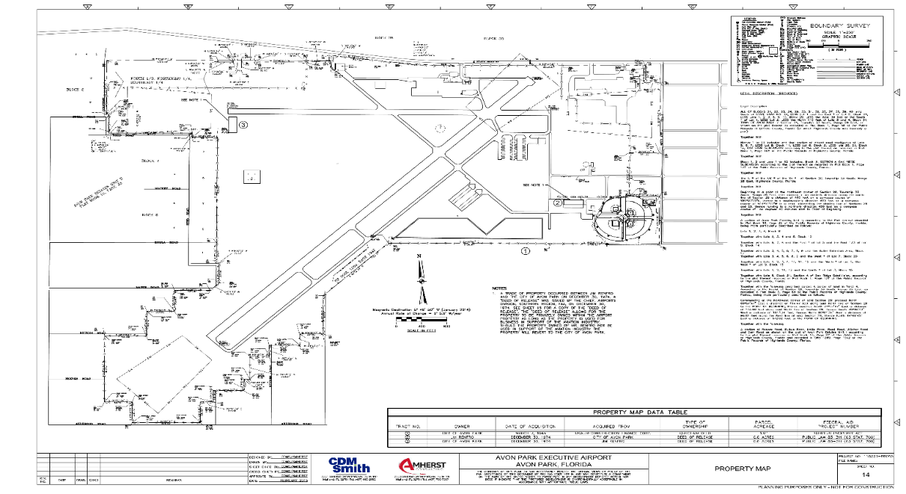

Figure 4- Property Map from the Avon Park Airport Master Plan (Signed 11-16-2016)

Part III. Terms of the Lease Transfer

☒A. A detailed description of the terms of the lease transfer, other than financial, including:
- Term of the Lease (this includes a total summary of the lease – see Attachment for Part III, Item 1 for the draft lease agreement.)
2. A description of any rights, authority, or interests retained by the public sponsor, including reversion of title to facilities.
3. If the private operator is a consortium, a description of the respective rights and responsibilities of each member.
Summary of Avon Park KAVO Draft Lease Agreement (this responds to items 1, 2 and 3 above)
The City proposes to lease the Airport to FAM KAVO, LLC. A copy of the proposed lease is attached to this Application as Attachment Part III, Item A. The following is a summary of the key provisions of the proposed lease. It is not intended to be a comprehensive review of the lease but instead to highlight topics the City believes are most pertinent to FAA’s review.
FAM KAVO’s General Rights at the Airport
FAM KAVO will take possession of the entire Airport with two exceptions: the City’s utility facility and a baseball field. (Section 2.1 and Exhibit A). The City will assign its existing leases at the Airport, other than that to Classic Caladium (e.g., those with hangar tenants, etc.), to FAM KAVO. (Section 2.3). FAM KAVO will assume operating and maintenance responsibility for the existing aeronautical facilities at the Airport (Section 2.4) and obtain title to certain existing equipment currently owned by the City and used at the Airport (Section 2.5).
Term
The initial term of the lease will be thirty (30) years. (Section 3.1). Subject to certain conditions (including benchmarking and performance standards) and City Council approval, FAM KAVO may renew the lease for two (2) option terms of ten (10) and nine (9) years, for a total potential lease term of forty-nine (49) years. (Sections 3.2 and 3.3). FAM KAVO may terminate for its convenience within the first ten (10) years of the lease. (Section 5.15). The City may also terminate the lease for convenience at any time, subject to certain buyout requirements. (Section 21.3).
Rent to City
FAM KAVO will pay the City Base Rent calculated pursuant to an appraisal of the Airport. (Section 4.1). (Note that the Base Rent presently shown in the draft lease is based on an appraisal conducted in 2021. The City has commissioned an updated appraisal to set the Base Rent prior to execution of the lease.) The Base Rent will increase annually at the increase in CPI and will be reset every five years pursuant to a new appraisal of the Airport (or more frequently at the City’s request). (Section 4.2). FAM KAVO will also pay the City certain Additional Rent, which includes repayment of amounts advanced to the Airport by the City in prior years and any in future years. (Section 4.3). FAM KAVO will also be entitled to Rent Credits for investments it makes in aeronautical facilities at the Airport. (Section 4.4). Should FAM KAVO sell or refinance its interest in the Airport, the City will be entitled to a share of the proceeds as Transaction Rent. (Section 4.7).
FAM KAVO’s Operating Rights and Obligations
FAM KAVO will take full responsibility for the operation and maintenance of the Airport and must do so in accordance with FAA and FDOT standards. (Sections 5.1 through 5.5 and 5.10, and Article 10). FAM KAVO will be required to employ or contract with key employees and sufficient staff to operate the Airport. (Article 34). FAM KAVO will be obligated to comply with existing and future grant conditions and assurances. (Section 5.6). FAM will be permitted to conduct various aeronautical functions and activities at the Airport on a non-exclusive basis. (Section 5.9). FAM will be permitted to sublease portions of the Airport on certain conditions, including attorning those agreements to the City in the event of the termination of the City-FAM KAVO lease. (Section 5.11 and Exhibit C). FAM KAVO will be authorized to assess and collect fees, rents, and charges for use of the Airport, but must do so in a reasonable and nondiscriminatory manner, and any increases to those fees beyond the increase in CPI annually are subject to City approval. (Section 5.12 and Exhibit O).
FAM KAVO’s Financial and Recordkeeping Obligations
FAM KAVO will provide the City with annual budgets and financial reports. (Section 6.1). FAM KAVO will also consistently maintain an operating bond equal to the annual operations budget for the Airport. (Section 6.2), and an increased Handback Bond within three (3) years of the expiration of the lease (Section 6.5). FAM KAVO will provide monthly operating reports to the public and the City (Section 6.3) and maintain its own financial records for City or FAA audit if requested. (Sections 7.1 and 7.5).
FAM KAVO’s Mortgage Rights and Restrictions
Under certain conditions, FAM KAVO will be permitted to execute leasehold mortgages on its interest in the Airport, but specifically may not mortgage the City’s fee interest in the Airport or any interest in the aeronautical facilities owned by the City. (Section 12.1(b)). The City will retain the ability to terminate the lease for defaults, and the leasehold mortgagee will have the ability to cure those defaults provided it ensures continued operation of the Airport. (Section 12.5(d)(4)). All leasehold mortgages will be subject to the City’s authority to operate the Airport in accordance with FAA and FDOT standards and grant assurances. (Section 12.9).
Capital Construction
FAM KAVO will be required to undertake capital construction as shown on the Airport’s Master Plan, which may be updated by FAM KAVO with the approval of the City. (Sections 19.1 and 19.2). With the City’s assistance, FAM KAVO may apply for grant funds to assist with this construction. (Section 19.3 and Article 25). FAM KAVO will be permitted to undertake additional construction at its own cost provided that title to any such improvements revert to City ownership at the end of their useful life or the expiration of the lease. (Sections 19.7 and 19.8).
City Ability to Ensure Continuity of Operations
If FAM KAVO fails to operate the Airport as a public airport, maintain safety and security functions of the Airport, or comply with Applicable Law or the applicable requirements under any Grant Agreement (defined in the lease as “Critical Functions”), the City may assume operations of the Airport to ensure continuity. (Sections 21.1(d) and 21.2(a)). The City will retain additional rights to operate the Airport in the event of FAM KAVO’s bankruptcy. (Section 21.7). A more detailed discussion of the bankruptcy provisions is provided below, and in Greenberg Traurig’s attached bankruptcy opinion that is being finalized and will become part of Attachment Part III A.
Miscellaneous Compliance Provisions
The lease will be subordinate to the City’s federal grant assurances and deed obligations. (Article 31). The lease incorporates the USDOT/FAA required contract provisions, including those applicable to grant-funded construction. (Section 40.4 and Exhibits H-1 and H-2). The FAA is specifically named as a third-party beneficiary of the lease. (Section 40.13). The City reserves to itself the right of flight over the Airport and FAM KAVO will be required to comply with Part 77. (Section 40.14).

- If the public sponsor will share ownership of the operating entity, a description of the respective rights and responsibilities of the public sponsor and private owners of the operating entity.

Avon Park will have no ownership of the private entity.

☒B. Financial terms of the transaction:
- Amounts and timing of payments to the public sponsor.
Master Lease/Operating Agreement - FAM Lease Forecast

The assumed rent is approximately $67,000 per year in year one of the lease and this will be increased by the annual Consumer Price Index – General each year during the term of the lease. Once every five years the market rate will be revisited, and the rent adjusted based on this updated market analysis. The City may request an appraisal in the interim if major improvements or new additions are added to the Airport funded by government grants that would increase the value of the annual rent.

The assumed rent was based on an appraisal that is over two years old. The starting amount rent will be established fair market rent pursuant to an appraisal that will be completed toward the end of the AIPP application process prior to the lease being executed to provide the more current market analysis. The updated appraisal will be provided to FAA for review and approval prior to lease execution.

The lessee may receive rent credits for investments into aeronautical facilities that are made with FAM’s funds.

FAM will be able to earn a reasonable return on investment as outlined in the draft lease agreement as outlined below and in more detail in the draft lease agreement.

The portion of Net Revenues available to Lessee shall be as follows:

- For all Net Revenue between One Dollar ($1.00) and Two Hundred Fifty Thousand Dollars ($250,000), Lessee shall be entitled to retain ninety percent (90%) of such Net Revenues;
- For all Net Revenue between Two Hundred Fifty Thousand and One Dollars ($250,001) and Five Hundred Thousand Dollars ($500,000), Lessee shall be entitled to retain eighty percent (80%) of such Net Revenues;
- For all Net Revenue between Five Hundred Thousand and One Dollars ($500,001) and One Million Dollars ($1,000,000), Lessee shall be entitled to retain sixty percent (60% of such Net Revenues);
- For all Net Revenue between One Million and One Dollars ($1,000,001) and Two Million Dollars ($2,000,000), Lessee shall be entitled to retain fifty percent (50%) of such Net Revenues;
- For all Net Revenue between Two Million and One Dollars ($2,000,001) and Three Million Dollars ($3,000,000), Lessee shall be entitled to retain thirty percent (30%) of such Net Revenues; and
- For all Net Revenue above Three Million and One Dollars ($3,000,001), Lessee shall be entitled to retain fifteen percent (15%) of such Net Revenues.

The Net Revenues that are not retained by Lessee pursuant to clauses above shall be deposited in a special account and expended by the Lessee (or the Lessor) solely for the capital and operating costs of the Airport or other local facilities owned or operated by the Lessor or the Lessee and directly and substantially related to the air transportation of passengers or property.

☐C. Copies of all documents executed as part of the transfer, to be provided as they are executed or are in sufficiently final form to indicate the substantive nature of the expected final document.

All attachments to the draft lease agreement as shown in the lease agreement are also part of this AIPP application. Key items include:
- General Required Federal Provisions
- Construction Required Federal Provisions
- Required Sublease Provisions
- Property survey and legal description
- Building Asset List
- Equipment Asset List
- List of Tenant Leases to be transferred from the City to the lessee
- Lessor Approvals Requiring City Council Action
- Performance standards
- Certificate of Insurance (sample shown in Attachment Part III A.
- Initial Budget Pro-forma
- Initial Rent Appraisal (will update with new appraisal for FAA review prior to lease execution)

☒D. If applicable, a request for confidentiality of any document or information submitted, with supporting information.

Florida Airport Management (FAM) requests that certain business information be treated as confidential business information. Disclosure of certain sensitive and highly confidential business and financial information would cause substantial competitive harm to FAM’s ability to undertake future airport acquisitions in pursuance of its long-term business model. FAM believes that its commercial leasing model and other related commercially sensitive information or intellectual property should be treated as trade secrets and confidential commercial or financial information, and, therefore, this information should be confined to the use of the Secretary and the FAA under the Pilot Program regulations, and not be made available for public disclosure other than as otherwise currently required by law. More Specifically, FS 688 USTA, FS Chapter 288 Commercial Development and Capital Improvements, FS Chapter 119 Public Records, and FS Section 119.071 1.c, 119.071 3., 119.071 4.

☒E. Provisions of a document conferring third-party beneficiary rights on behalf of the FAA to enforce, directly against the private operator, key obligations contained in AIP grant agreements and the assurances required by section 47134.

See Section 40.13 of the draft lease agreement provides that the FAA is a third-party beneficiary of the lease and may enforce the terms and conditions of the lease to ensure the statutory objectives of 49 USC 47134 are satisfied. These third-party beneficiary rights are enforceable by the Secretary and the FAA in administrative or judicial legal proceedings.

Part IV. Qualifications of the Private Operator

☐A. A complete description of airport management and operations experience, including the identity, experience, expertise, and responsibility of key personnel. A description of the facilities and airports presently being managed by the company, both domestically and internationally. If the private operator is a newly formed entity, describe the experience of the constituent members and the proposed management structure to integrate operational functions.

FAM

Florida Airport Management (FAM) is a new company created specifically for the long-term lease of the Avon Park Executive Airport with the intent of managing this and additional public general aviation airports. FAM will have served as the Airport Management Team under contract with the City for approximately one year (April 11th Start Date) at the time of submittal of this AIPP application by the City to the FAA. The FAM Team members have decades of experience in airport management, airport planning, and implementation of capital improvement program projects. Our leadership is experienced in aviation management within the State of Florida and has managed the Avon Park Executive Airport under a Management Agreement since April 2022, that the City has required as a transition with the intent of executing the AIPP program application process successfully. This includes meeting staff certifications, FDOT inspections and follow up, review and planning to move forward with the JACIP.

FAM has committed its leadership and staff to an Operational Readiness and Transition Plan (ORTP provided herein) that has been agreed upon with the City of Avon Park (The City) and is in full consideration of the Standards of Practice set forth by FAA Guidelines. FAM understands the importance of compliance with FAA Guidelines, Federal and State of Florida Guidelines and Statutes, and local municipal ordinances. FAM AVO Implementation Team members (see below) have over 30 years of experience working on FAA and FDOT Grant Assured Projects (see section 4.e) from inception to completion.

FAM AVO Year One Achievements
During the time from April 2022 to the present FAM has performed the following:
- Met and established a strong relationship with Local FAA ADO and FDOT representatives.
- Performed daily airfield inspections according to FAA Part 139 guidelines.
- Performed daily fuel inspections according to FAA Part 139 guidelines.
- Realigned the AVO Joint Agency Capital Improvement Plan (JACIP) with 2023 cost projections.
- Established tenant outreach communications program.
- Performed the ORTP Facility Assessment for 2022.
- Prioritized maintenance and replacement program projects according to Safety and Security issues.
- Provided NATA Training for all on site FAM employees at AVO.
- Updated the Airport Rates and Charges, approved by the City Council

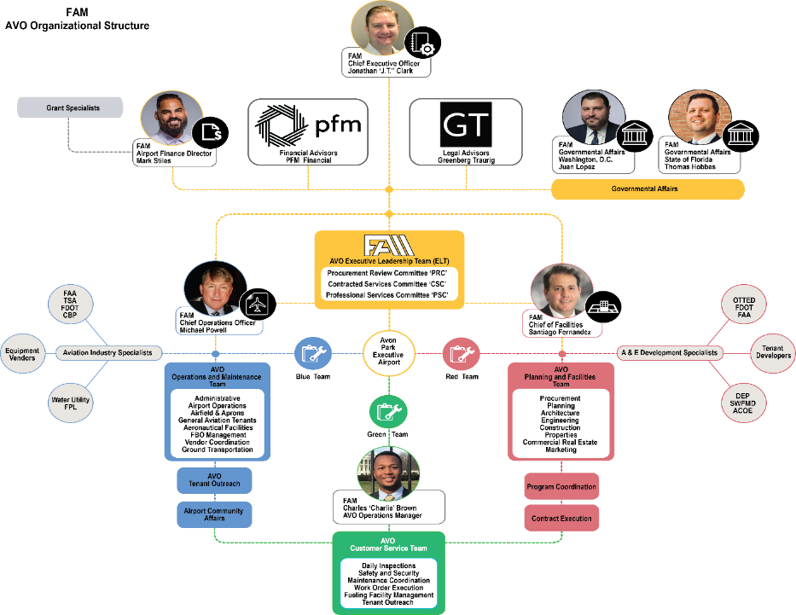
Our Team

FAM Detailed Organizational Structure
This chart expresses our organizational structure for FAM at AVO. Please note that FAM has submitted a defined set of procurement protocols in keeping with FAA, FDOT guidelines. To ensure that grant assurances are met throughout its tenure, FAM Leadership and staff will abide by our set of procurement protocols as documented in our lease agreement and provided herein as Appendix 4.a.


FAM Executive Leadership Team
Jonathan ‘JT’ Clark is Chief Executive Officer for FAM and will serve as the Contract Executive with the City of Avon Park. Jonathan brings 20 years of operations management and experience to AVO. Jonathan has been in oversight of the FAM AVO Executive Leadership (ELT) and AVO Management Team (The Team) in service at AVO throughout the 2022 Management Agreement between FAM and The City of Avon Park. FAM understands that it will serve as the fiduciary of all interests, public and private, at AVO throughout the negotiated lease term. FAM anticipates coordinating with the City on all issues of importance, risk, and value contractually requiring the City’s consent as required under the lease agreement. Resumes of Key Personnel are provided in Appendix IV.A- FAM Resumes.

The Law offices of Greenberg Traurig (GT) are currently advising FAM on the AIPP transition and will serve as Legal Counsel to FAM in management of the contract. GT will advise the Team on all issues of procurement of goods and services throughout the contract term. Furthermore, GT represents FAM on the Bankruptcy Opinion provided for this AIIP transaction.

The Law Offices of Shuffield Lowman represents FAM on corporate governance and real estate transactions.

PFM Financial is currently serving as financial advisor to FAM regarding bond market finance opportunities all FAA AIP and FDOT Grant ineligible Capital Improvement Program projects as well as, on all Non-Aeronautical Economic Development Projects.

The AVO leadership is responsible for working closely with the Implementation Team to ensure that all Federal Regulations, State Laws and Local Ordinances and Grant Assurances are complied with (See section on FAM Committees and Procurement Cycle.

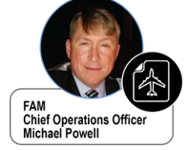
FAM AVO Implementation Team
Michael D. Powell, C.M., ACE, is a State of Florida licensed Airport and Spaceport Operator and will serve as Chief Operations Officer throughout the contract term. Michael brings thirty years of airport management experience to the Team and will be focused on Aeronautical Business at AVO. Michael will be in oversight of all operational safety and security at AVO. Michael will provide guidance for compliance with FAA Part 139 standards at AVO. He has prior experience at four (4) Florida airports over his 30-year career.

Mr. Powell will be the Team lead on administrative tasks, airport operations, airfield & apron management, general aviation tenant interface, management of aeronautical facilities and infrastructure, FBO Management, Vendor Coordination and Ground transportation services.
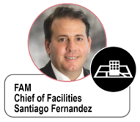
Santiago Fernandez will serve as Chief of Facilities and will oversee all development at AVO throughout the Contract Term. Mr. Fernandez has served as General Consultant, Master Planner, Program Manager, for multiple Florida airports over his 32 Year Career. He will be responsible for oversight on the planning and development of physical facilities and infrastructure at AVO. Mr. Fernandez will oversee procurement of professional services, and project delivery contractors as well.

Mr. Fernandez will be the Team Lead in oversight of planning, architecture, engineering, and construction specialists as well as work together with commercial real estate advisors and marketing advisors to promote AVO facilities.

Mr. Powell and Mr. Fernandez will serve as points of contact for Operations and Facilities respectively and will perform outreach to government agencies such as City of Avon Park, FAA, TSA, Florida Department of Transportation (FDOT), CBP, environmental agencies and others as required. Professional Service Providers and vendors will solicit our airport team on an open forum with Mr. Fernandez and Mr. Powell present as necessary.

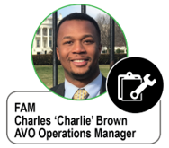
Charles ‘Charlie’ Brown will serve as the AVO Operations Manager and will perform daily services in support of operations at AVO. Mr. Brown is NATA Certified in safety inspection. Mr. Brown will be responsible for daily Inspections of the airport, general safety and security inspections, and fuel farm service and inspections. Mr. Brown will perform coordination with maintenance contractors and be in oversight of work order execution. Mr. Brown will support Mr. Powell with daily tenant outreach and discovery of issues and opportunities at AVO. Refer to Appendix IV.A for a full resume and links to individuals provided.

Our Experience
Please see Appendix Part IV.A FAM Resumes for information about our Key Personnel experience.

☒B. Financial resources for operating/ capital expenses of the airport. Copies of the 10K annual reports filed in the past three years with the Securities and Exchange Commission, if filed. If 10K annual reports were not filed, provide a balance sheet and income statement prepared in accordance with Generally Accepted Accounted Principles, with all footnotes applicable to the financial statements. The private operator should have a letter of credit equal to cash reserves of six months for the initial operation of the airport unless a lower amount is approved in advance by the FAA.

FAM KAVO L.L.C., is a special purpose entity formed for this transaction, is pre revenue and has no balance sheet or income statement.

☒C. Timing and details of application for Part 139 certificate, if applicable.

N/A

☒D. Plan for compliance with 49 CFR part 1542 is approved with FDOT.

FDOT Contact:
Mr. Greg Jones
Airspace and Land Use Manager
Aviation Office
Florida Department of Transportation

Tallahassee, FL 32399-0450
Office 850-414-4502
Fax 850-414-4508
Greg.Jones@dot.state.fl.us
http://www.fdot.gov/aviation

☒E. A description of the private operator’s capability and experience of complying with the public sponsor’s existing grant assurances, including the assurance of compatible land use around the airport; the protection of navigation aids, approach lights, runway safety areas, and runway protection zones; and the continuation and extension of navigation easements.
Grant Applications and Grant Assurances will be submitted and complied with by Michael Powell and Santiago Fernandez, with combined sixty years of experience identifying project needs, preparing scope documentation, and executing grant assurances at Florida Airports.
As The COO of FAM, Michael Powell will be in oversight of all aeronautical facility improvement projects. Mr. Powell managed three airports simultaneously for The Titusville Cocoa Airport Authority (TCAA) over a period 18 years before joining FAM. Mr. Powell was directly responsible for applying for grants and ensuring all grant assurances were met throughout his tenure. During these 18 years, all project compliance requirements were met throughout. Below is the percentage of funding from Federal, State and Local Agencies for 28 projects delivered by Michael over his tenure with TCAA. Two charts are provided in the more detailed descriptions in Appendix Part IV for your review.
Santiago Fernandez will be assisting Mr. Powell in the execution of similar projects at AVO over the tenure of the contract. Mr. Fernandez has over thirty years of airport planning experience and has served to develop capital improvement programs including space needs assessments, cost to benefit analysis and project budgets for FAA Grant application and Exhibit ‘A’ updates. The Chief Operations Officer and the Chief of Facilities for FAM will be fiduciaries of grant assurances on all projects budgeted and performed throughout the contract. FAM will ensure the useful life of all improvements to Avon Park Executive Airport.

☒F. Affiliations with air carriers or other persons engaged in aeronautical business activity at an airport (other than airport management).

N/A

☒G. A description of all charges of unfair or deceptive practices or unfair methods of competition brought against the private operator and private operator’s key personnel; and, in the case of a private operator that is a joint venture, partnership, or other consortium, the separate members of the entity in the past 10 years. The description should include the disposition or current status of each such proceeding.
FAM has had no actions filed against it for any illegal labor practices or actions, as defined by the National Labor Relations Act (NLRA) and/or by Florida labor laws.

☒H. Any other pending civil litigation against the private operator or its key personnel.
There is no pending litigation regarding any aspect of FAM or Avon Park airport.

Part V. Requests for Exemption

☒A. Describe the specific exemption requested by the public sponsor under 49 U.S.C. 47134(b)(1), from the prohibition on use of airport revenue for general purposes, including the amount of funds involved. The description should include sale or lease proceeds as well as funds in existing airport accounts that would be transferred to general accounts.
Revenue Use Exceptions for KAVO AIPP Application
Pursuant to 49 U.S.C. § 47134(b)(1)A)(ii), the City of Avon Park (the “City”), as the airport sponsor, and Florida Airport Management KAVO, LLC, the lessee (“Lessee”) of Avon Park Executive Airport (KAVO) (the “Airport”), hereby request that the Secretary of Transportation, acting through the Federal Aviation Administration (“FAA”) grant an exception to the City from the provisions of 49 U.S.C. §§ 47107(b) and 47133 (and any other law, regulations, or grant assurances) to permit the City to recover from the lease of the Airport the following amounts: the annual Base Rent to be paid by the Lessee to the City during the term of the lease to be entered into between the City and Lessee of the Airport (the “Lease”), in substantially the form submitted to the FAA with this application under the Airport Investment Partnership Program. The Base Rent payments shall be based upon the fair market value of the land and existing facilities located at the Airport as of the effective date of the Lease and shall escalate annually by the increase in the consumer price index (“CPI”). The City estimates that the Base Rent in year one of the Lease will be $67,000 (to be updated by a current appraisal reviewed and approved by FAA prior to lease execution). In addition, the City expects to recover certain amounts advanced by the City in fiscal years 2016 - 2023 from certain other funds of the City to the Airport enterprise fund to pay for operations and maintenance costs not recovered by the City from tenants at the Airport in those fiscal years in the aggregate amount of $657,924.11.
As required by 49 U.S.C. § 47134(b)(1)A)(ii), the City has consulted with at least 65 percent of the owners of aircraft based at the Airport regarding the proposed Lease, the Base Rent and the recovery by the City of Base Rent and other funds as described above. The amount in the existing Airport Enterprise Fund as of September 30, 2023, $975,756 , shall be available to be transferred by the City to the appropriate fund that advanced the funds to the Airport. See Appendix Part V.A.

☒B. Describe the specific exemption requested by the public sponsor under 49 U.S.C. 47134(b)(2) from the requirement to repay Federal grant funds or return property.

Pursuant to 49 U.S.C. § 47134(b)(2), the City seeks the exemption from the Secretary from provisions of 49 U.S.C. §§ 47107(b) and 47152 (and any other law, regulations, or grants assurance) to the extent necessary to waive any obligation of the City, as airport sponsor, to repay to the Federal government any grants, or to return to the Federal government any property, received by the City under Title 471, the Airport and Airway Improvement Act of 1982, or any other law. The City notes that under the most recent amendments to Section 47134, the grant of this waiver is mandatory if the exception requested in paragraph V.A above is granted by the Secretary.
The City has received the following federal grants:
Apron Rehab Design (FAA) Grant No. 3-12-0004-021-2021 ($166,666)
ACRGP (FAA) Grant No. 3-12-0004-022-2021 ($13,000)
ARPA (FAA) Grant No. $32,000
CARES (FAA) Grant No. 3-12-0004-020-2020 ($30,000)
Mowing Equipment (FDOT) Grant No. G1L28 ($135,383)
Taxiway F Reconstruction (FAA, FDOT) Grant No. 3-12-0004-019-2019 $1,429,029/Grant No. G1C48 ($143,402)
Runway 523 Rehab (FAA, FDOT) Grant No. 3-12-0004-018-2017 $1,414,890/Grant No. ARA01 ($442,666)
Fuel Farm (FDOT) Grant No. ARN87 ($454,023)
Fuel Truck (FDOT) Grant No. G0716 ($125,000)
T-Hangar Demo (FDOT) Grant ARB96 ($137,072) – partially received, grant terminated by FDOT
FEMA Drainage (FEMA, COUNTY) Agreement No. 1561-93R / Project #1 – unknown total amounts awarded project started in 2007 completed sometime in 2014-2015

☒C. Describe the specific exemption requested by the private operator under 49 U.S.C. 47134(b)(3) from the prohibition on use of airport revenue for general purposes. The description should include the anticipated amount of airport revenue to be used for compensation of the private operator, the source of airport funds involved, and a description of the effect, if any, on air carrier and other aeronautical user fees.

Pursuant to 49 U.S.C. § 47134(b)(3), Florida Airport Management requests an exemption from the provisions of 49 U.S.C. §§ 47107 and 47133 and any other law, regulation, or grant assurance to the extent necessary to allow FAM to earn compensation from the operation of the Airport, including the ability to earn, retain, and use for purposes of payment of debt, distributions to equity holders, payments under the Lease Agreement, or otherwise, all of the compensation and/or net revenues from airport operations that it earns in accordance with the Lease and including a reasonable rate of return on the private operator’s investment and risk undertaken in operating AVO. The Lessee notes that under the most recent amendments to Section 47134, grant of this waiver is mandatory if the exception requested in paragraph V.A above is granted by the Secretary.
FAM will be able to earn a reasonable return on investment as outlined in the draft lease agreement as outlined below and in more detail in the draft lease agreement.

The portion of Net Revenues available to Lessee shall be as follows:

- For all Net Revenue between One Dollar ($1.00) and Two Hundred Fifty Thousand Dollars ($250,000), Lessee shall be entitled to retain ninety percent (90%) of such Net Revenues;
- For all Net Revenue between Two Hundred Fifty Thousand and One Dollars ($250,001) and Five Hundred Thousand Dollars ($500,000), Lessee shall be entitled to retain eighty percent (80%) of such Net Revenues;
- For all Net Revenue between Five Hundred Thousand and One Dollars ($500,001) and One Million Dollars ($1,000,000), Lessee shall be entitled to retain sixty percent (60% of such Net Revenues);
- For all Net Revenue between One Million and One Dollars ($1,000,001) and Two Million Dollars ($2,000,000), Lessee shall be entitled to retain fifty percent (50%) of such Net Revenues;
- For all Net Revenue between Two Million and One Dollars ($2,000,001) and Three Million Dollars ($3,000,000), Lessee shall be entitled to retain thirty percent (30%) of such Net Revenues; and
- For all Net Revenue above Three Million and One Dollars ($3,000,001), Lessee shall be entitled to retain fifteen percent (15%) of such Net Revenues.

The Net Revenues that are not retained by Lessee pursuant to clauses above shall be deposited in a special account and expended by the Lessee (or the Lessor) solely for the capital and operating costs of the Airport or other local facilities owned or operated by the Lessor or the Lessee and directly and substantially related to the air transportation of passengers or property.

Part VI. Certification of Air Carrier Approval

☒A. For an application relating to a primary airport:
This does not apply.

☒B. For an application relating to a nonprimary airport:
- Provide certification that the public sponsor has consulted with at least 65 percent of the owners of aircraft at the airport regarding the sponsor’s application for the exemption described in Part V.A. above.
- Copies or a description of the information conveyed to aircraft owners at the airport regarding the proposed exemption.
- Copies of comments received from aircraft owners on the proposed exemption.

Please see Attachment Part VI, B. for the certification, survey document and summary of results.

Part VII. Airport Operation and Development

☒A. Provide a description of how the private operator, the public sponsor, or both will address the following issues with respect to the operation, maintenance, and development of the airport after the proposed transfer (See Appendix VII. A, ORTP 2023).

1. Part 139 certification. If applicable, a request for a Part 139 certificate should be filed with the local FAA Regional Airports Division. The exemption application needs only to reflect the private operator’s intentions and the status of a certificate application, if applicable.
N/A

2. Continuing access to the airport on fair and reasonable terms and without unjust discrimination, in accordance with section 47134(c)(1).

FAM will ensure that the Airport will continue to be available for public use on reasonable terms and conditions and without unjust discrimination. FAM will base all future agreements on fair market value principles applied. FAM will apply reasonable rules and regulations without unjust discrimination and apply reasonable minimum operational and development standards to all tenant contracts. FAM will comply with all lease provisions and ensure the AVO continues to be operated as a public use airport.

3. Continued operation of the airport in the event of bankruptcy or other financial or legal impairment of the private operator, in accordance with the specific terms of section 47134(c)(2).

In the event of bankruptcy, the City of Avon Park will assume responsibility for AVO federal obligations. Section 21.7 of the lease grants the City the right to step in and operate the Airport if FAM is unable due to bankruptcy. See Attachment Part III A. is a legal opinion of FAM’s legal counsel, Greenberg Traurig, that the provisions of Section 21.7 are enforceable in the event of FAM’s bankruptcy (note this is in process and will be provided).

4. Maintenance, improvement, and modernization of the airport, in accordance with section 47134(c)(3), including the public sponsor’s most recent 5-year capital improvement plan and the 5-year capital improvement plan proposed by the private operator. Applicants should identify the sources of funds to be used for capital development, including any continuing contributions by the public sponsor.

FAM submitted to the City and will perform as Sponsor all tasks identified in the AVO Operational Readiness and Transition Plan (ORTP). An outline of this document was included in the FAM Management Agreement Contract April 22, 2022. This includes the execution of the most recent Capital Improvement Plan as identified in the Avon Park Executive Airport 2014 Master Plan. Please find the fully Executed ORTP2023 submitted for and included in this AIPP Application in 2023 to the City of Avon Park and included as Appendix Part VII, A.4.

5-Year Capital Improvement Program

FAM as the Private Operator will prioritize projects according to these categories as follows:

- Safety and security
- Deferred maintenance
- Life cycle renewal and replacement
- Cosmetic improvement

FAM will update the JACIP with the Avon Park City Council’s vision for airport improvements set forth in the 2014 Master Plan. FAM intends to execute these projects through the final full term of the JACIP in 2028. This is currently the focus of our 5-Year Capital Improvement Program Plan.

The following Chart is an explanation of the 2014 MPU Projects that have not yet been executed (in yellow) and the 2014 MPU Projects that were executed (in blue). Those projects not executed to date were estimated in 2015 dollars and will be reviewed for accuracy and revised to current market pricing as part of the ORTP. There remains a total of 13 projects from the originally identified 17 projects to be funded and performed totaling $14,366,000 in 2015 dollars.

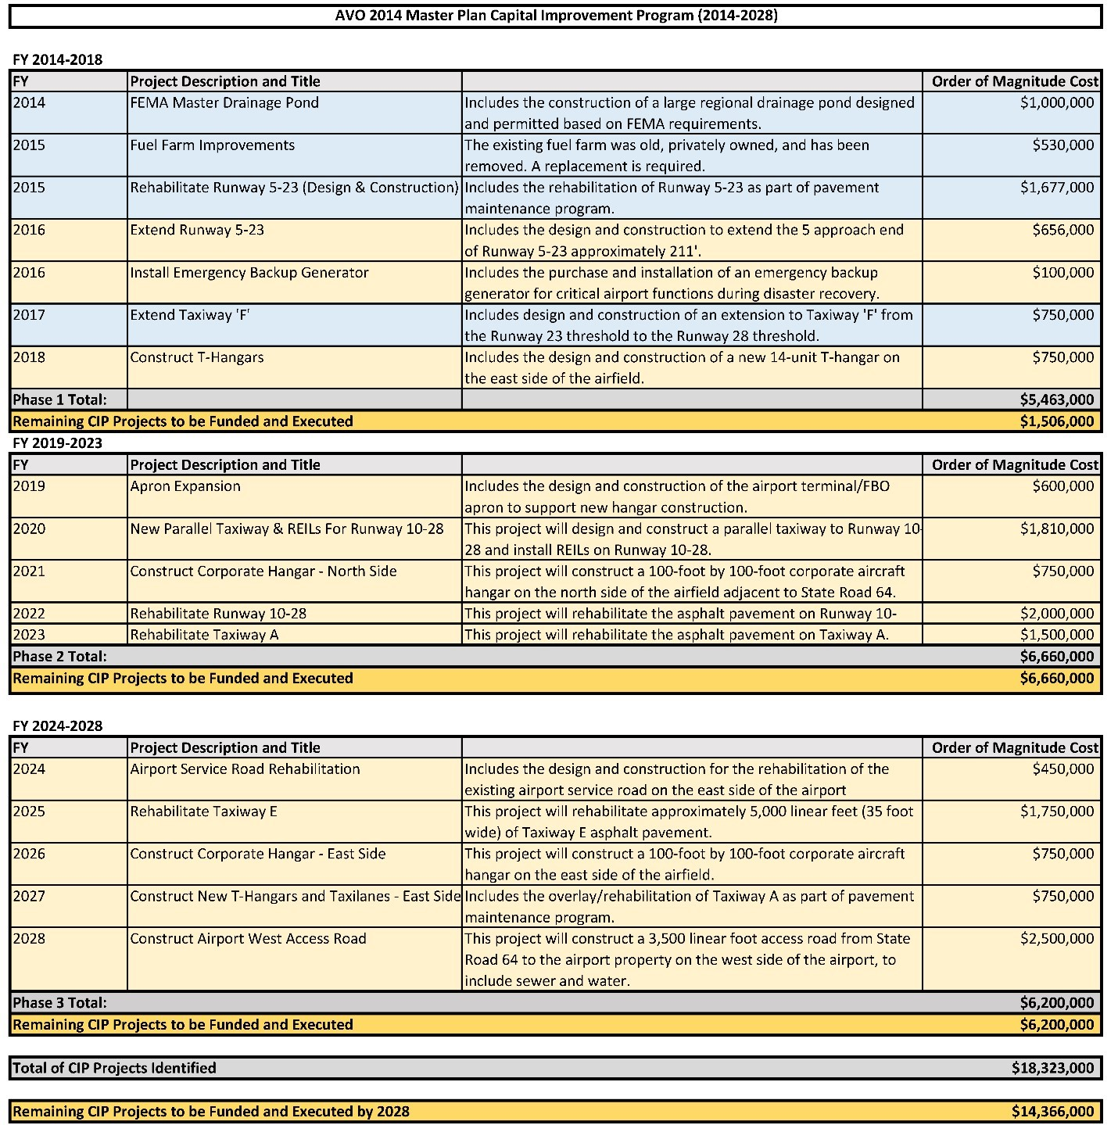

Figure 5- Chart Showing APMPU 2014 Projects Executed V. Need to Be executed in 2015 Dollars.

Based on 30 Years of experience with Capital Improvement Projects at similar airports, FAM anticipates that these projects will be funded from Federal, State, and local resources. FAM anticipates private equity funding to be accessed throughout the erm of the lease. The following is a sample of how we understand the percentage funding from current sources of funding to be available to FAM for execution of Projects at AVO.

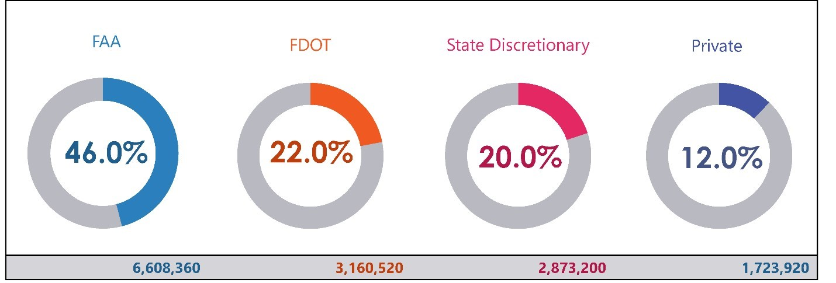
Figure 6- Chart Showing Anticipated Percentage of Contribution by entity on 5-Year CIP Projects

Anticipated Funding Sources for execution of 5-Year CIP

AVO is considered a major public asset in REDI counties and will ideally have access to state DEO funding as well as state aviation fund dollars. FAM anticipates that as an asset in a rural county the FDOT will waive the need for match funding on CIP projects.

If funds are to be borrowed, applicants should identify the expected sources, anticipated repayment terms of any borrowed funds, and the source of revenue to be used for repayment.

There is no anticipated debt financing at this point.

Applicants should also include any financial security provisions, such as a letter of credit or performance bond, for the accomplishment of the maintenance, improvement, and modernization projects committed to by the private operator.

As outlined in the lease agreement included in Attachment Part III, FAM must provide a bond for the amount of one year of operating budget. In addition, FAM must accumulate funds and/or provide a bond over the last few years of the term to ensure there are adequate funds to provide repairs or renovations for any property that has not been maintained to an acceptable level over the term of the lease.

Performance and payment bonds are required by State of Florida law on all capital improvement projects. FAM will ensure these bonds are provided as outlined in Florida law.
Insurance is also required by all consultants and contractors that provide services to FAM as the lessee. FAM has a Certificate of Insurance in place now for the Management Agreement that will continue under the lease agreement and is required by the lease to provide minimum levels of coverage and minimum limits during the term, which may be revisited if necessary or appropriate.
5. Compliance with the limitations on air carrier fees, pursuant to section 47134(c)(4), not imposed for funding of new capital development undertaken after the transfer to the private operator. If it is the private operator’s intent to impose an increase in fees on air carriers exceeding the limit in section 47134(c)(4), provide:
N/A
6. Compliance with the limitation on general aviation fees described in section 47134(c)(5).

The lease agreement provides for an annual fee increase up to (but not exceeding) the annual increase in Consumer Price Index – General. Any increases above this level will require submittal to the City Council for review and approval.

7. Maintenance of safety and security at the airport, in accordance with section 47134(c)(6). The application should note the applicant’s contacts with the FAA Regional Airports Division or Airports District Office on Part 139 and TSA on Part 1542 but does not need to duplicate information filed in connection with those actions. The application should include planned efforts by the private operator to maintain the public sponsor’s existing mechanisms for communicating with airport tenants and users and the public on safety and security issues.
Maintenance of safety and security at the Airport will consist of inspections and/or repairs to the perimeter fence to help ensure positive access control. Attention will be given regarding gaps under the fence (in excess of 3 inches), chains and locks on all non-electric gates, monitoring excess separation between gates to minimize wildlife and unauthorized access to the airfield environment, as well as maintaining all electronic gate access for proper operation. FAM will be implementing MaintainX software to track all inspections, log deficiencies, and generate work orders to track any deficiencies through resolution.
Daily airfield inspections will be conducted for Foreign Object Debris (FOD) removal, damage to any signs or lighting, compliance with paved edges, pavement condition, as well as safety areas.
Routine coordination will be maintained with the Orlando Airports District Office (ADO) as well as FDOT District One for any discrepancy that may be identified and put into JACIP for grant funding, if AIP eligible.
An up-to-date contact list will be maintained of all t-hangar tenants and commercial businesses for routine communication and to schedule inspections of their facilities. Notice to Airmen (NOTAMs) will be issued as required for changed conditions on the airfield to maintain safety. If needed, messages can also be added to the Automated Weather Observation System (AWOS) for issues such as increased bird activity, although that is not currently a problem at AVO.

- Mitigation of adverse effects of noise from airport operations, in accordance with section 47134(c)(7). The applicant should specifically describe its intentions with respect to an existing or future Part 150 noise compatibility program for the airport, with respect to the public sponsor’s commitments under past records of decisions on airport development projects, and other measures the private operator proposes to take in the future.
Avon Park Executive Airport is currently underutilized with infrequent aircraft operations. As the Airport develops and grows, mitigation of adverse effects of noise from Airport operations will be addressed in all future Master Plans, as needed, based on planned strategic development and/or increased aircraft operations as well as size of aircraft utilizing AVO. Voluntary Noise Abatement (VNAP) for Avon Park Executive Airport are as follows:
No touch-and-go operations between 8pm and 8am
No repetitive flight operations at the Airport between 8pm and 7am
No repetitive flight training operations on Sundays and national holidays
In lieu of touch-and-go operations, perform full stop, taxi-back operations
Avoid flying at low altitudes over noise sensitive areas

- Mitigation of adverse effects on the environment from airport operations, in accordance with section 47134(c)(8).

Mitigation of adverse effects on the environment from Airport operations will be addressed through daily inspections to identify any potential issue, e.g., fuel leaks/spills from aircraft and around the fuel farm in conjunction with the implementation of a Spill Prevention Control and Countermeasure (SPCC) Plan. FAM will utilize sorbent booms for running spills, sorbent diapers and kitty litter will be used, as necessary, to clean up any environmental issue and protect the pavement to help ensure the Airport gets useful life out of its improvements.

- Confirmation that any collective bargaining agreement that covers employees of the airport and is in effect on the date of the sale or lease of the airport will not be abrogated by the sale or lease, as required by section 47134(c)(9).

N/A

- The private operator’s intentions regarding consultation with general aviation users regarding the planned privatization of the airport, and the projected effect on general aviation of the proposed changes in operation and management of the airport.

FAM has been operating AVO under a Management Agreement since April 2022. During that time there have been routine interactions with tenants and discussions on FAM and the process for moving AVO forward. Some examples are shown in this graphic and below.

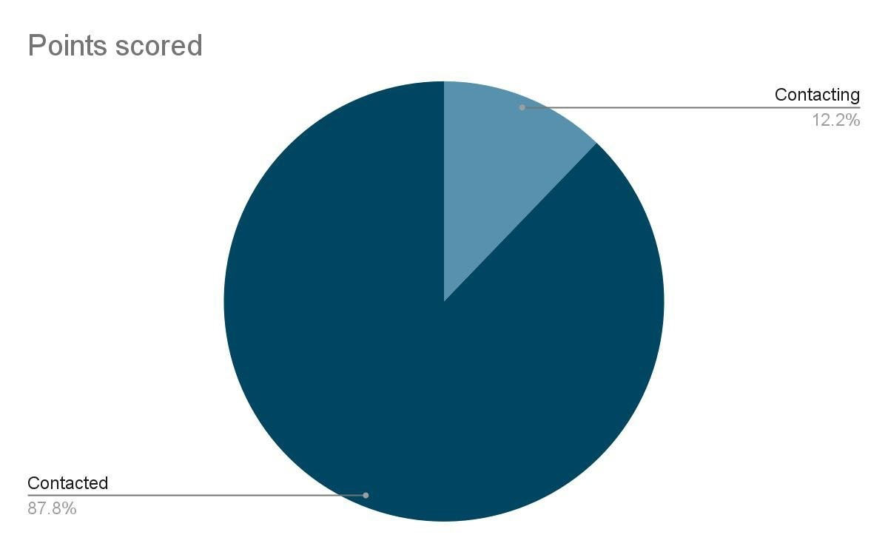
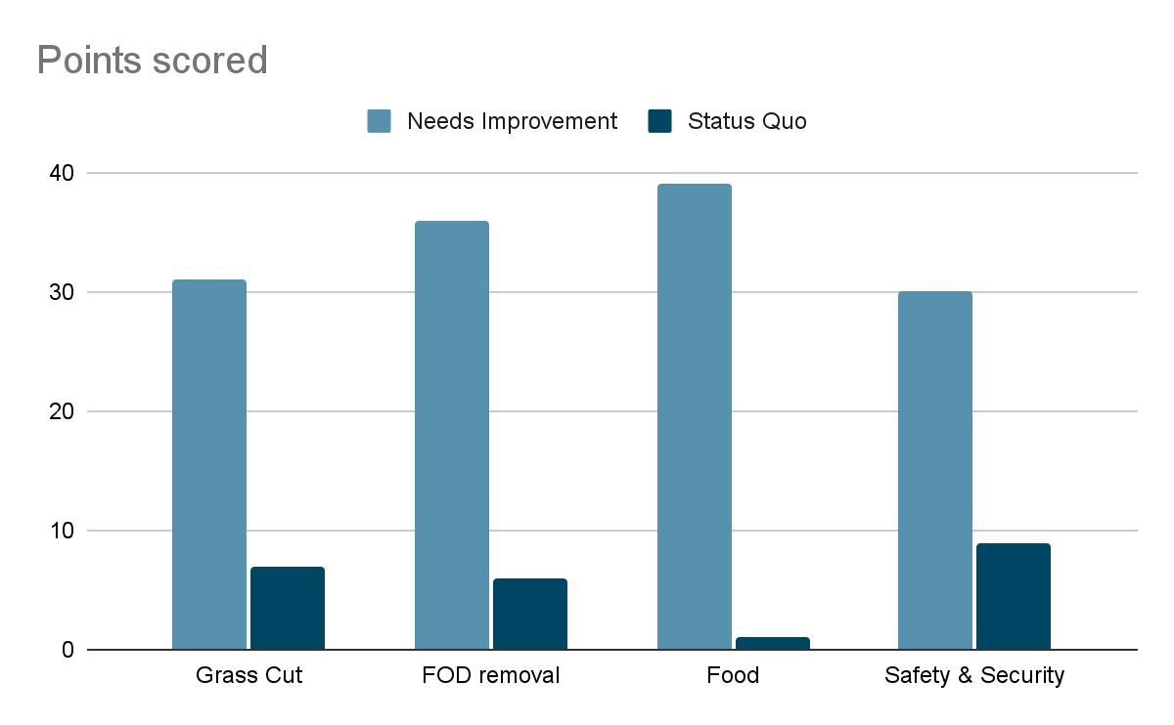

Tenant | Date Contacted | Answer | Voicemail left | Called Back | Google Survey Sent | Survey Completed
Jeff Biter | 3/22 | N | Y | Y | Y | Y
Jerry Kiella | 3/22 | N | Y |  | Filled out in person | Y
Jerald Bruce | 3/22 | N | Y | Y | Y | Y
Ultra Dent Tools Fletcher | 3/23 | N | No, box full | Y | Y | Y
Lee Townsend | 3/23 | N | Y |  | Y | Y
Jim Tidmarsh | 3/23 | N | Y |  | Y | Y
Tim Karr | 3/23 | N | No, box full |  | N | N
E.A.S. Industries | 3/23 | Y |  |  | Y | Y
Cheryl Noll – Hinson | 3/23 | Number not in service |  |  | N | N
Robert Jordan | 3/23 | Number not in service |  |  | N | N
Joseph Vrechek | 3/23 | Number not in service |  |  | N | N
Jay Shirer | 3/23 | N | Y |  | Filled out in person | Y
George Clifton Pope | 3/23 | Y | Y |  | Y | Y
David Galati | 3/23 | Y |  |  | Y | Y
Everrett Winston | 3/23 | Y |  |  | Filled out in person | Y
Thomas O'Conner | 3/23 | Y |  |  | Y | Y
Carlo Consola | 3/23 | Number not in service |  |  | N
Shelby Air | 3/23 | Y |  |  | Filled out in person | Y
Mike Rohrer | 3/26 | Y |  |  | Y | Y
Kenny Long | 3/26 |  |  |  | Filled out in person | Y
William Pisarello | 3/26 | N | Y | Y | Filled out in person | Y
Rick Hayes | 3/29 | N | Y |  | Filled out in person | Y
Missionary Aeroplanes | 3/29 | N | N |  | Y | Y
Julio Rincon | 3/29 | N | Y | Y | Y | Y
Lotela Partners | 3/29 |  |  |  | Y | Y
James Jordan | 3/29 | Y |  |  | Y | Y
Ronald Rheude | 3/29 | Number not in service |  |  | N | N
Brian Ohrt | 3/29 | Number not in service |  |  | N | N
3192 Golf Inc | 3/29 | Number not in service |  |  | N | N
George Karamitis | 3/29 | Y |  |  | Filled out in person | Y
Paul Kiser | 3/31 | Y |  |  | Filled out in person | Y
Peter Nagy | 3/31 | Y |  |  | Filled out in person | Y
Arthur Stifel | 3/31 | Y |  |  | Y | Y
Gregory Scott Carkeet | 3/31 | Y |  |  | Y | Y
William Keith Davis | 3/31 | Y |  |  | Y | N
Frank Bagwell | 3/31 | Y |  |  | Y | Y
Charles McLochlin | 3/31 | Y |  |  | Y | Y
Thomas Williamison | 3/31 | Y |  |  | Y | Y

Private operator’s plans (if known) for development of general aviation.
FAM has been operating AVO since April 2022. During that time safety, security, and operations for general aviation have been improved. FAM will continue to improve the general aviation operations at AVO.

In addition, FAM is focused on implementing the AVO Master Plan to provide more opportunities for items such as:
  - Increase available services at the FBO
  - Develop more aircraft hangers to base more aircraft at AVO
  - Increase alternative tenants at AVO
  - Promote Intermodal Logistics for Tenants
  - Develop Public Private Partnerships to foster a growing Workforce.
  - Develop Avionics & Tech-Based Businesses at AVO

- The private operator’s acceptance of the grant assurances contained in the public sponsor’s grant agreements with the FAA and intention to assume legal responsibility for compliance with those assurances, as reflected in the transfer documents. Assurance 25 need not be addressed. In addition, the applicants’ agreement that the grant assurances and the assurances required for granting an exemption under section 47134 create third-party beneficiary rights enforceable by the FAA in an administrative or judicial legal proceeding, and permit FAA to enforce directly against the private operator the grant assurances and the assurances required for granting an exemption under section 47134.

Florida Airport Management will make all airport records including deeds, leases, operation, use agreements, and regulations available for inspection by the FAA Secretary upon reasonable request, including FAA Form 5100-126 Financial Government Payment Report and FAA Form 5100-127, Operating and Financial Summary. FAM will also maintain a current ALP in conformity with all applicable FAA design standards and criteria. FAM will also maintain a current Exhibit “A” airport property map for submittal with all grant agreements.

- Provide a description of the parties’ efforts to consult with airport users about the proposed transaction and of the parties’ community outreach efforts.

The City of Avon Park City Council has advance notice of public council meetings that include the meeting agendas. The City Council provides the ability for the public to attend in person or via Zoom to participate in public meetings. The City Council has held public meetings to discuss various elements of the proposed public-private partnership, lease agreement, financial terms and related elements at numerous public meetings over the past two years. Any meeting agendas can be provided if requested as these are extensive documents and are open to public view. See the Background section for more information.

In addition, Florida Airport Management has conducted a survey of over 85% of tenants at Avon Executive Airport by creating a Google survey which was completed, along with calling each tenant to gauge concerns. FAM has also attended local Farm Bureau meetings to conduct a consensus of the local farmers and see if FAM can work with local families on airport improvement. The City of Avon Park held several meetings to allow the local public to voice their concerns and make recommendations for future growth. The City has also had several write ups in the local paper notifying the local community of the transaction between FAM and the City.

Part VIII. Periodic Audits

☒A. Section 47134(k) provides that the FAA may conduct periodic audits of the financial records and operations of an airport receiving an exemption under the pilot program. Applicants should indicate in the application their express assent to this provision.
Pursuant to the requirements of 49 U.S.C. 47134 (k), FAM expressly agrees to the Secretary, U.S. Department of Transportation, conducting, at its discretion, periodic audits of the financial records of, and the operations at Avon Park Executive Airport.
In addition, FDOT or the City may also review records at their discretion

