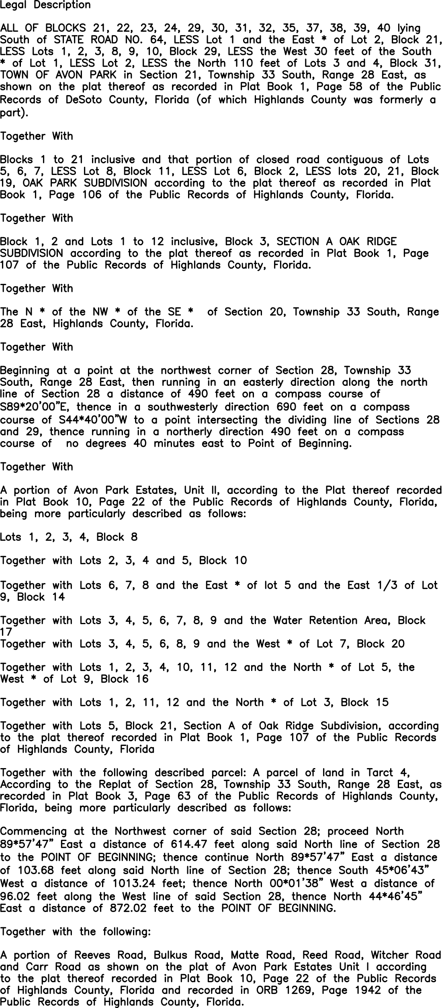

Rest of Page not used





**Parcel Information Diagram**

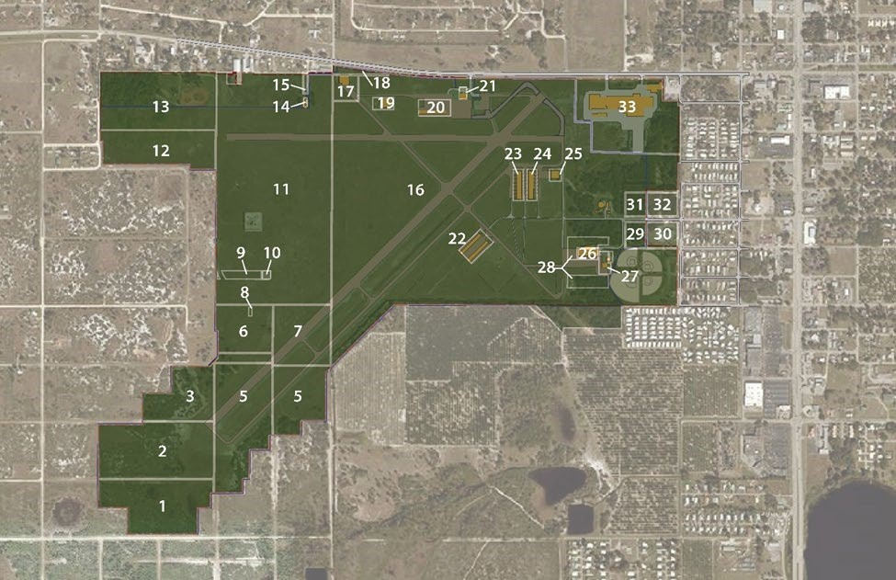

The above Diagram depicts the 33 identified parcels that currently comprise Avon Park Executive Airport. Parcels 9-33 define the boundaries of the original civil airport that was built in 1940. The boundaries of Parcels 1-7 were acquired by purchase in later years legal descriptions are described below for parcels 1-7 and legal record as evidence of good title is attached in Appendix II.D for these parcels.

An itemized list of all 33 parcels is provided below identifying the Parcel Legal Description Address of Owner and DOR Code as designated by the Highlands County Property Appraisers office. A link to the GIS Parcel information page of the Highlands County Property Appraiser Office Website is provided as well.