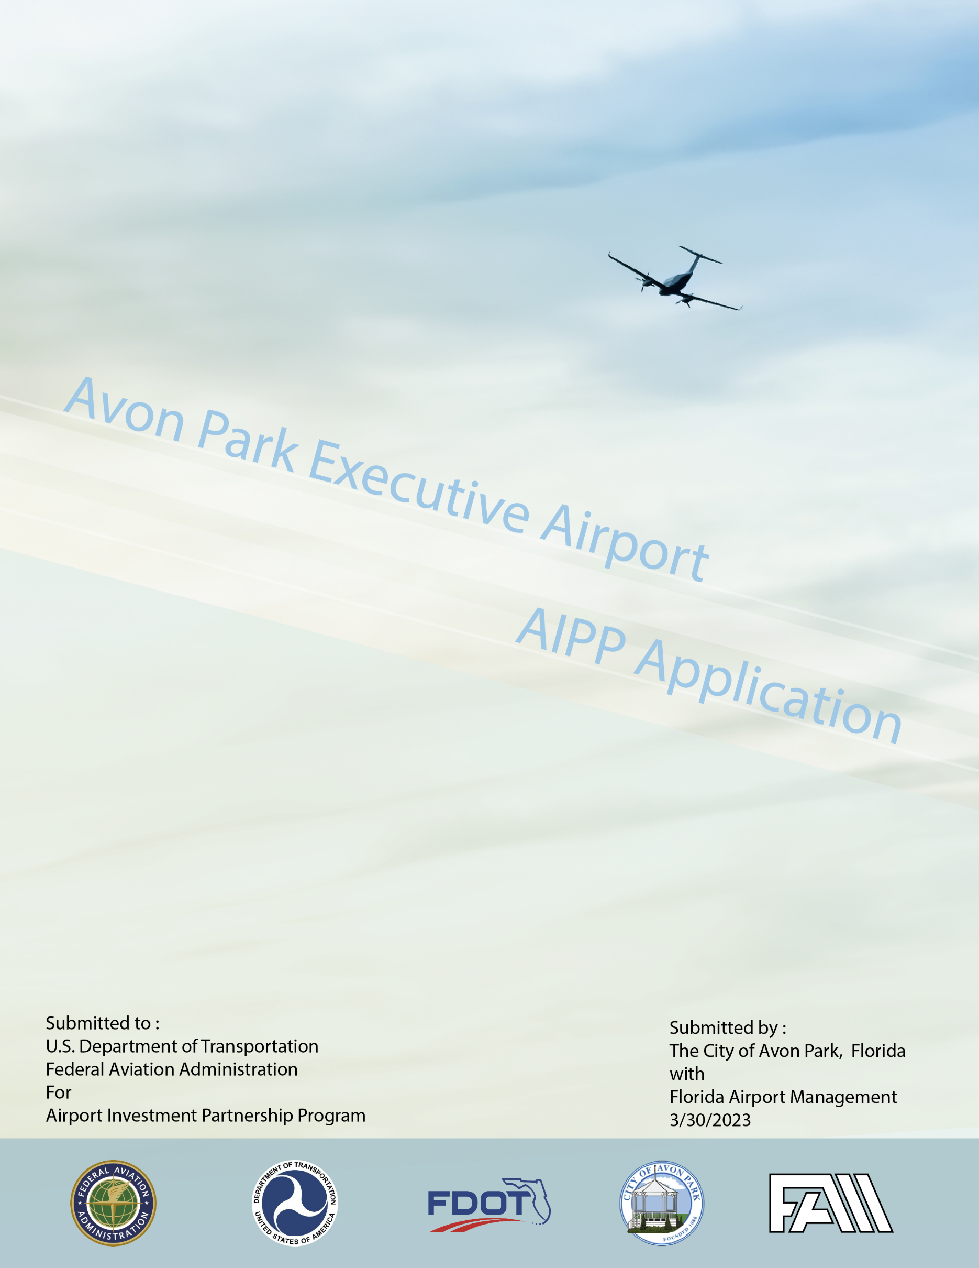
Attachment
Table of Contents
Tied to the AIPP Application Section
Part I. D. If the private operator proposing to purchase or lease the airport is a partnership, joint venture, or other consortium of multiple interests, the name and address of each of the participating members.
Item 1 – Flowchart and description of ownership structure for Florida Airport Management KAVO, LLC and parent company.
Item 2 – Florida Airport Management KAVO, LLC, Articles of Incorporation
Item 3 - Florida Airport Management KAVO, LLC, Operating Agreement
Item 4 – Florida Secretary of State registration for Florida Airport Management KAVO, LLC
Part I. G. A statement of the public sponsor’s authority to sell or lease the airport, with a citation to legal authorities.
Item 1 – Summary of Legal Authority for the City of Avon Park to enter a long-term lease for the Avon Executive Airport provided by the Avon Park City Attorney
Part II. A. - For each airport included in the application, a description of the airport property to be transferred. Applicants should describe property in sufficient detail to identify the parcels of property and facilities to be transferred.
Item 1 – Exhibit A for Avon Park Executive Airport
Item 2 – Current Avon Park Executive Airport Layout Plan
Item 3 – Current Avon Park Executive Airport Property Map - Property Map from the Avon Park Airport Master Plan (Signed 11-16-2016)
Part II. A.2/Part II D. – Legal Description of the Property, Evidence of Good Title
Item 1 –List of Airport Parcels (included in current version of AIPP application)
Item 2 – Survey of Avon Park Executive Airport to be Leased through the AIPP process (in process)
Item 3 – Title Search and any deed restrictions for portion of Avon Park Executive Airport to be Leased through the AIPP process (in process)
Item 4 – American Land Title Association Commitment
Part II.A.3.2 – Building Descriptions
Item 1 – Building Summaries
Part III. A./Part VII. Draft Lease Agreement
Item 1 – Draft Avon Park Executive Airport Long-Term Lease
Item 2 – Opinion of Proposed Lessee Legal Counsel on Bankruptcy provisions and process (in process)
Part III. B – Financial Provisions
Item 1 – Original Appraisal for non-AIPP approach – setting tentative value for the annual rent
Part III. C. – Required Items for Lease Close
Item 1 – Current Certificate of Insurance as example for Certificate of Insurance for the Long-Term Lease
Part IV. A. – Description of the Proposed Lessee including qualifications
Item 1 – Resumes of key staff for Florida Airport Management KAVO, LLC
Item 2 – Summaries and Resumes of financial/legal/technical support for Florida Airport Management KAVO, LLC
Part V.A. – Waiver Items
Item 1 – Exhibit that outlines prior advances from the City of Avon Park to the Avon Park Executive Airport proposed for eligibility to be reimbursed from future Avon Park Executive Airport revenues through the proposed Long-Term Lease with Florida Airport Management KAVO, LLC
Part VI. B. – Survey for Non-Primary Airport
Item 1 – Certification that the City Surveyed more than 65% of the Avon Park Executive Airport tenants
Item 2 – Survey used for tenants
Item 3 – Summary of tenant responses
Part VII. A. 4. – Transition Plan
Item 1 – Transition Plan from the City of Avon Park to Florida Airport Management KAVO, LLC – Please note that Florida Airport Management, LLC (the parent of Florida Airport Management KAVO, LLC, has been under contract with the City of Avon Park to operate and maintain the Avon Park Executive Airport since April 2022 and will continue to do so under a 20-year agreement pending the proposed AIPP application.

